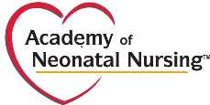
Spring National Advanced Practice Neonatal Nurses Conference
May 29 - June 1, 2019 / Hyatt Regency Indian Wells / Greater Palm Springs, CA

CREDIT CARD AUTHORIZATION FORM

In order to charge your credit card and in accordance with the security measures taken by credit card companies, please fill in the following form and return.

Please send this sheet by fax or email scan to the attention of:
Lauren McKeown
ANN Exhibit Coordinator
Fax: 856-589-7463
Email: lauren.mckeown@ajj.com

Authorization for Credit Card Charges

Name of company:

We authorize ANN to make the charge of: (US currency only) $

For the following services:

For conference:

Credit card details to be charged:
☐ VISA ☐ MasterCard

Credit Card Number:

Expiration date: / Security Code

Name of card holder:

Address: (as per credit card records):

City: State: Zip Code:

Country:

Telephone number: - -

Email Address for receipt:

Signature of card holder: Date: / /

